**ENGR-UH 1000**

**Computer Programming for Engineers**

**(Universal Voices final term report)**

**Professor Mohamad Eid**

**Mariam Al-Omari, Micah Jessicah Hein and Maithaa Al Saiqal**

**Fall 2023**

**1.** **Introduction**

Our project is designed to address the critical need for effective American Sign Language (ASL) education through a virtual reality program. American Sign Language is a dynamic and expressive form of communication, vital for the deaf and hard-of-hearing individuals to effectively interact with the world around them. According to Gallaudet University, ASL is the sixth most common language in the United States.[1] The World Health Organization (WHO) estimates that over 5% of the world's population (466 million people) have disabling hearing loss, with a significant portion requiring accessible means of communication. ASL can be a valuable resource for them to engage in society.[2] Despite its importance, accessibility to quality ASL education remains limited, hindering the integration of this community into broader society. Our virtual reality program aims to bridge the educational gap and facilitate the integration of people with varying levels of ASL proficiency into the broader societal context by providing a comprehensive, interactive, and immersive platform for ASL instruction.

Our objective is to provide a platform to teach sign language, in an immersive learning environment, to anyone to better help them be able to communicate with the hard of hearing and vice versa. The program will be able to test a user’s knowledge and help them identify their problem areas when the course is completed.

**2.** **Project Development**

CODE GITHUB:

<https://github.com/MicahHein/CPE-Project.git>

**Game Setup:**

Once our user enters the game, they are placed outside a classroom and presented with a game description and explanation dialog with the purpose of this VR. Next to it, there will be three buttons providing the user with three options:

* Learn:
  + The user will be placed inside the classroom in a chair and a desk in front of them. There will be a menu of various topics in front of them that the user can choose from and press. When pressed, the topic button will display the specific video for that topic lesson. There will also be a mirror in front of them where they can practice what they are learning at the same time. The user can switch between topics at any time needed.
  + The lesson will consist of important words related to the topic in sign language with subtitles under each. Each sign is repeated for the user and shown from all possible perspectives.
* Quiz:
  + The user will be placed in front of the door inside the classroom where a menu of the topics will be presented to them to choose from. When the topic is chosen, the user will be smoothly moving to the desk and chair to take the quiz. There will be five buttons in one line on the desk, each have one word that the user would’ve already learnt in the learning part. The user will be warned before a video on the board starts playing. The video will show different signs without subtitles this time. The aim is for the user to press the right buttons in the correct order as shown in the video. The video on the board will be continuously looping so that if a user gets confused with the order, they can come back on track.
  + As the user presses an answer button, a wrong or correct text will display, telling the user if their answer was correct. Once the user has pressed all the buttons (finished the quiz), a dialog with their score will be presented in front of them (/5).
  + Two buttons will also appear: return to the main menu or return to quiz topic options. Depending on the learning style of the user, you can learn all the topics and do all the quizzes at once, hence you would go back to the topic menu to do another quiz. Or you can go back to the main menu and continue learning.
* Trip:
  + An exciting trip for the student! The user will be taken to an exciting trip in a medieval market, surrounded by different vegetables and fruits. The user will be presented with their challenge and they can press start trip to start the challenge. The user will move smoothly to the place of the challenge. There will be a table with three different objects and three baskets nearby each with a video playing on top of the hand sign. The user is supposed to grab the object by hand and place them in the basket under the correct hand sign. When the user is done, they can press the ‘check answers’ button that will show the right answers as words under the hand signs and the user can self-check their answers (it is a trip to have fun, no grades!) There will be a ‘return to main menu’ button that will take the user back to the classroom.

The user can continue learning and testing themselves as much as needed.

* Softwares used:
  + Unity
  + Visual Studio
  + Handbraker - to convert the videos from .mov to mp4

We started our project using a classroom asset that our instructor Pi provided for us and then we imported additional needed assets from unity: a Professor asset, a farmer’s market asset and a food asset. CITE HERE?

To create our immersive learning experience, we borrowed a tripod from the library and used our recording devices to film high quality, steady, constant videos of ourselves performing ASL, instead of utilizing pre existing resources that were not specifically catered for our desired needs and vision of our classroom. We grouped the videos into the different categories, we then clipped, subtitled and organized these videos tailoring them specifically to each function in our program that the user would need, which totalled more than 50 videos.

These videos would be projected onto a preexisting blackboard in the classroom, emphasizing our classroom atmosphere. We first created a plane and added a video player component to it, and the video clip to that component would change depending on what topic the player has chosen to learn/be quizzed on. A script for all the topic buttons includes which video should be played.

Video On board Example:

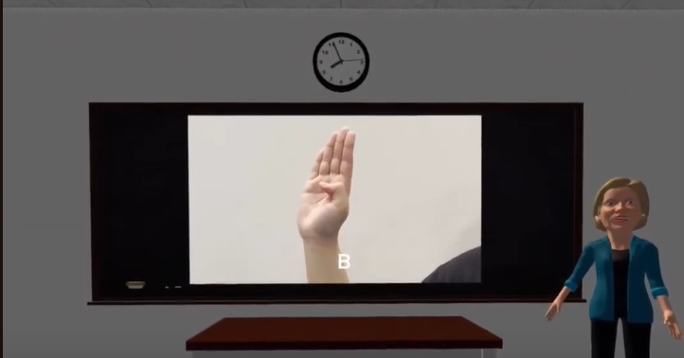

Each appropriate button is linked to its corresponding function in the inspector under “when select()”.

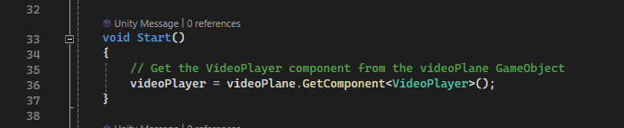

Example code for playing a video for a specific topic:

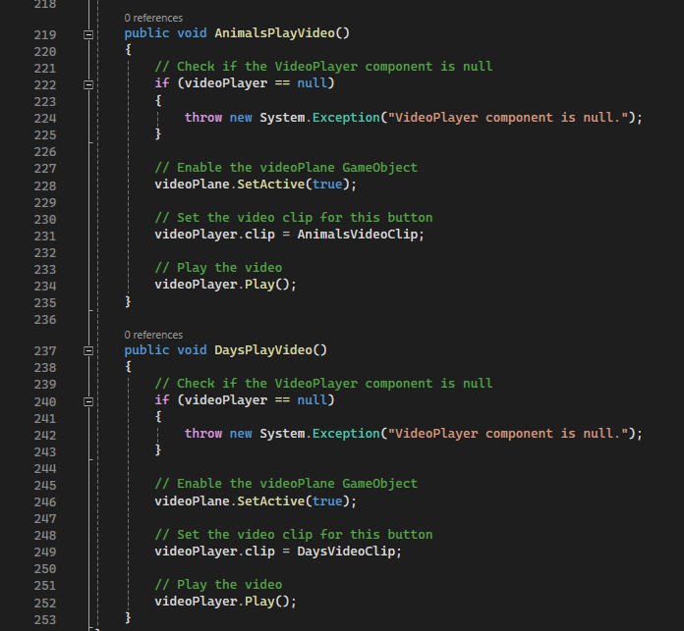

We also included a mirror that would be placed in front of the user while learning which allows them to see their hands while practicing from all perspectives: both from the front (by their natural view) and the back (by the mirror). This was done by creating a plane that would act as the mirror then creating a new material which we then attached to the plane. A source camera would then be created as a child of that plane, and we positioned it where we want the mirror to reflect the scene. Then, we created a renderer texture and we gave it the same ratio as the mirror dimensions to have perfect quality. The render texture is attached to the output texture of the camera and then to the plane’s material in the base map.

Mirror Code:

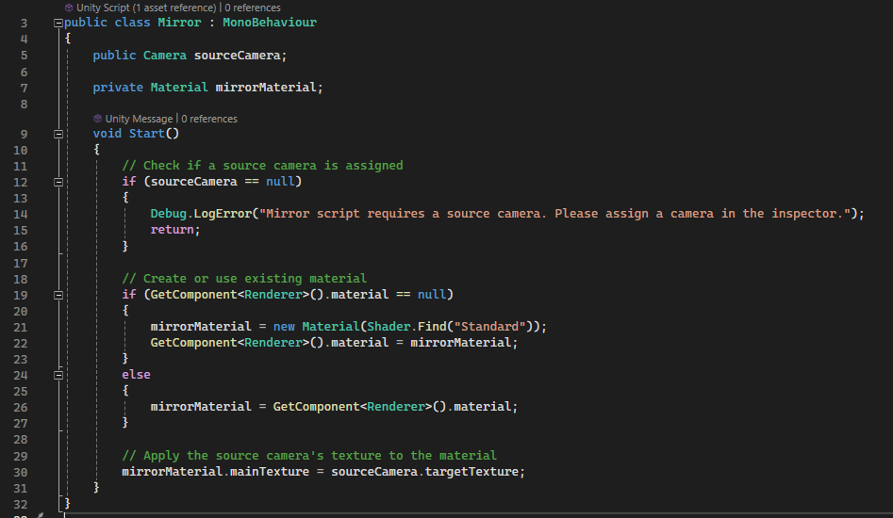

**Mirror in Scene**

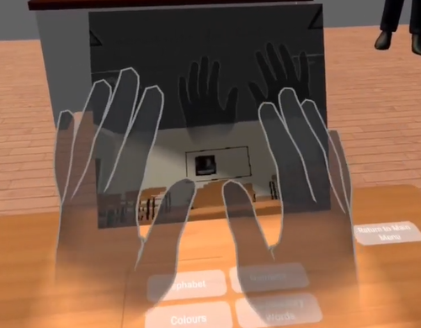

Below are the quiz/learn topics we implemented and the code. This is the menu displayed when the user is taking a quiz.

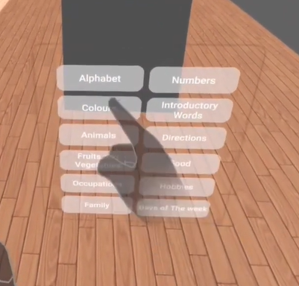

In the learn button code and quiz code the relevant game objects are turned on and the game objects either used prior or after are turned off depending on whether the student would want to learn or take a quiz, using the function SetActive(). In the learn button, we created a teleport function to teleport the player to the desk (to the quiz topics buttons in the case of the ‘quiz’ button). Similarly, the ‘return to main menu’ button which is always presented to the user on the desk at all times, would implement this function to return the user to the main menu’s position.

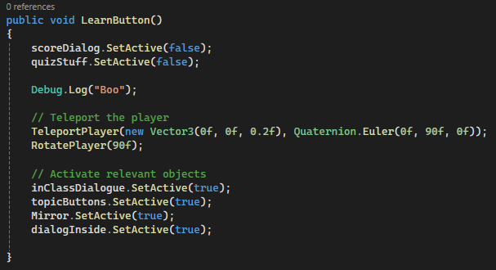

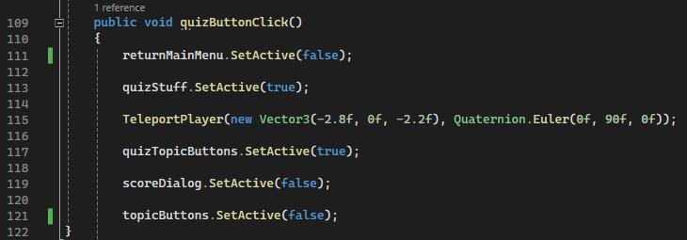

After choosing a quiz topic, the user smoothly walks to the chair behind the desk. Below is the code for smoothly walking the player:

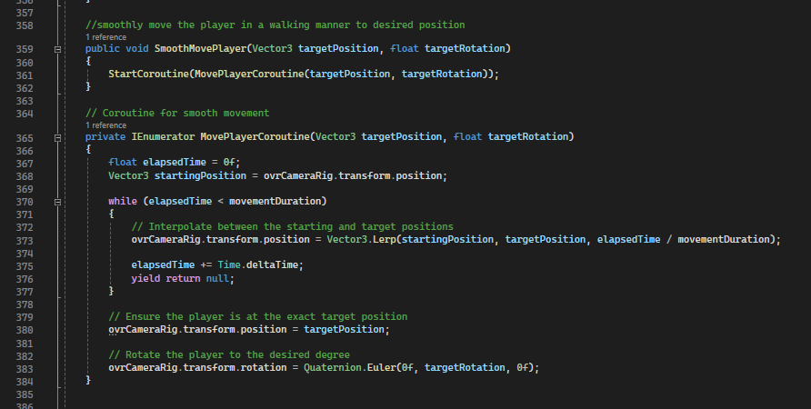

We used a coroutine which is often used for tasks that involve waiting for a certain period of time or performing actions over several frames and spreading an action across multiple frames without blocking the main thread. We used a while loop that makes sure the walking animation is done in a specified movementDuration which we previously set to 2 seconds. The line-by-line code explanation is shown as comments in the code in the image above.

Next, a video on the board, with a warning before starting, plays on the board with 5 different hand signs related to the topic, in a specific order. There will be 5 buttons in front of the user that each display the word as a text and the user has to keep track of the order of the hand signs shown in the video and subsequently press the buttons in the correct order (the exact order it was shown in the video). The user will get instant feedback on whether their answer is right or wrong. The video will keep on looping (turned on loop in the video player component of the quiz plane), in case the user gets distracted or loses track.

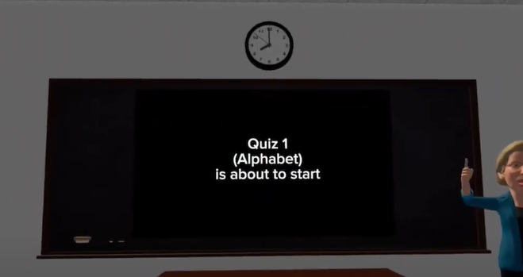

**Choice Buttons with feedback as the user presses:**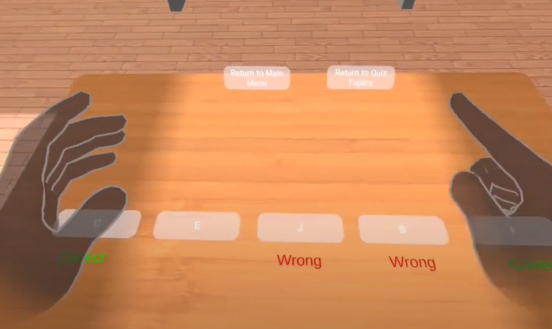

We created a script for each topic in the quiz, each will have two lists: one with the correct sequence in the specified order (depending on the topic the sequence will be different) and a user sequence. The correctSequence would be hard coded and the userSequence would start off empty and get updated as the user clicks on the choice buttons.

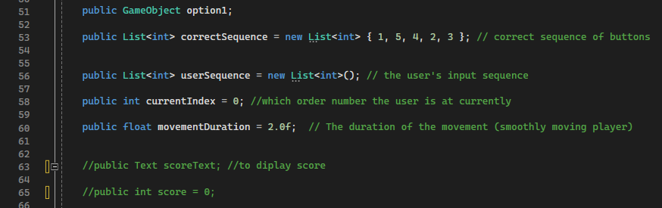

Below is an example of two button functions for the topic “Alphabets”. Each appropriate button would be linked to its corresponding function through the inspector, under “when select()”. We check if the currentIndex is less than five first so that the code block inside the if statement would not be executed if the user tries to press a button more than once (there are 5 buttons hence less than five in index). When a user presses a button while the currentIndex is less than 5, the number of the button (E.g. button one) would be added to the userSequence (1 would be added to the user sequence in this case). The userSequence at the currentIndex will be compared to the correctSequence at the currentIndex and whether they are equivalent or not, the ‘wrong’ or ‘correct’ feedback text will appear under the button. Finally, the currentIndex is incremented at the end of the if statement.

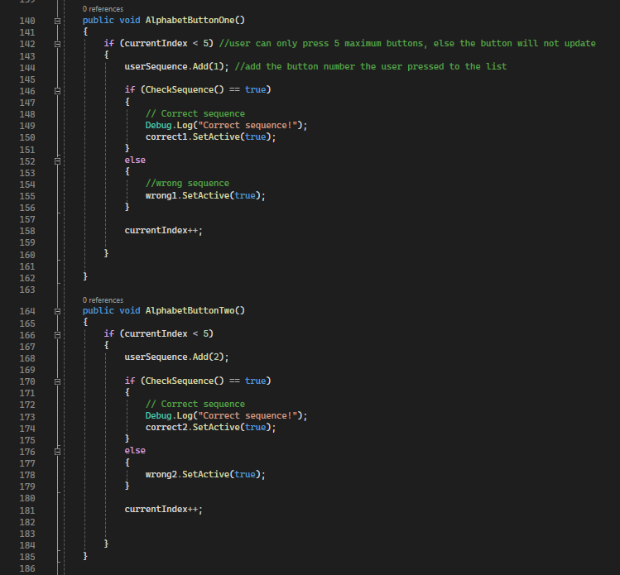

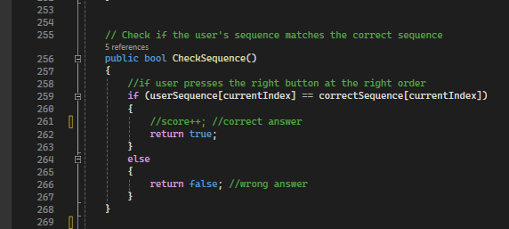

After the quiz, we can return to the menu or return to topics, in both cases, after the quiz, we teleport and hide irrelevant game objects and display relevant topics. We realized after trying to do multiple quizzes in succession, that the choice buttons would display incorrect answers and not work. This was easily fixed by clearing the userSequence and setting the currentIndex back to zero. Now the user can redo the quiz as needed.

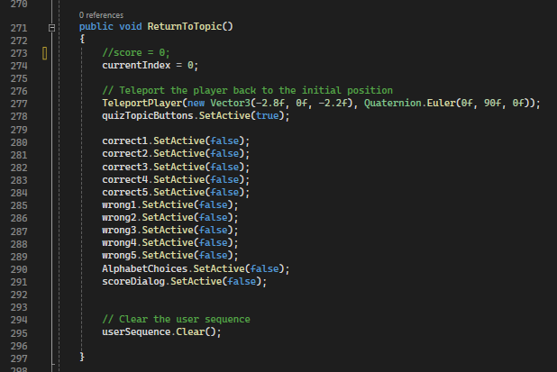

In our special feature of a trip, the player is taken to a new scene/asset: a farmers market. We included other food assets[6] that were not present in the farmer market that were specifically tailored to what the student had learnt before, reinforcing the knowledge the student had acquired previously.

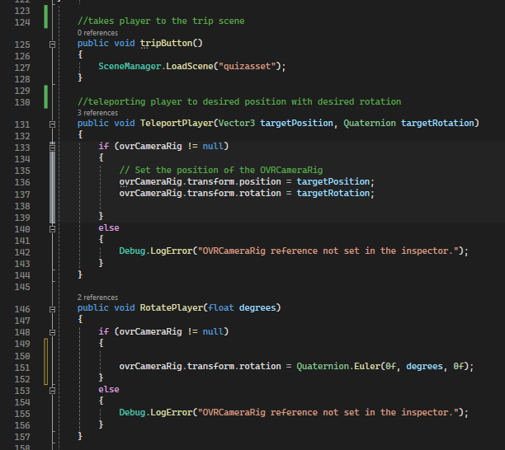

To take the player to the new scene we call the SceneManager.LoadScene, and then we will teleport the player to the correct position in the scene and rotate them as needed.

The player will be presented with a start challenge button and dialog in the trip. They will then be smoothly moved from one place to another. We wanted to make the player stop at different intervals when smoothly moving, but it was initially not working. We realized that we needed to use a coroutine since calling multiple smoothMovePlayer would not present the effect of stopping at the different intervals.

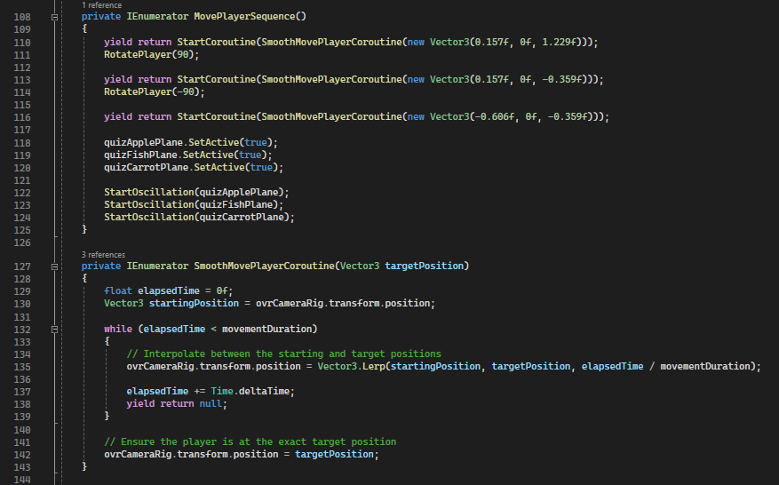

The player is taken to the challenge where they can grab the different objects and they have to put them in the basket that is under the appropriate video with the correct sign for that object which the user would have learnt previously. A similar process of displaying the videos as before was done.

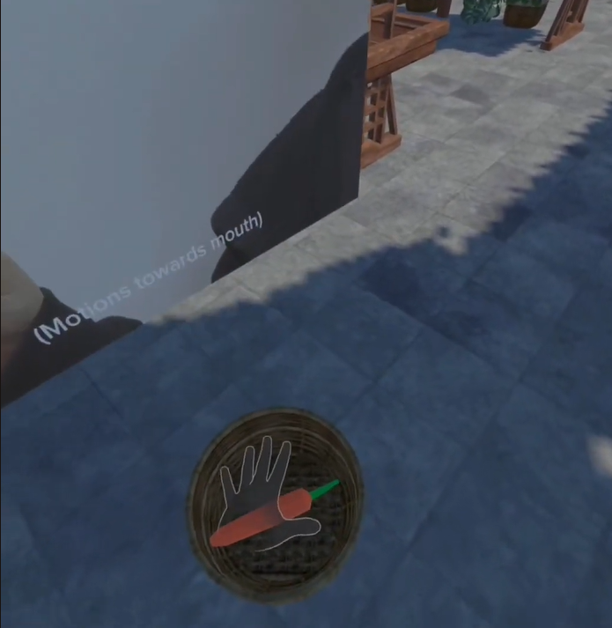 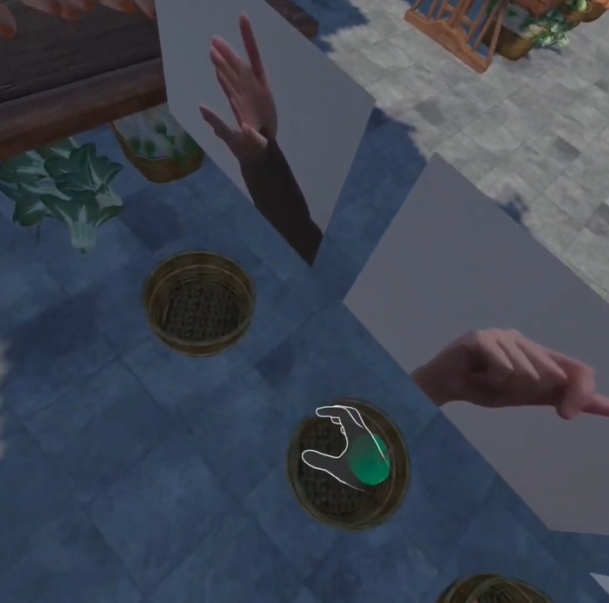

Furthermore, we added a nice effect of oscillating the planes up and down while the videos are playing.

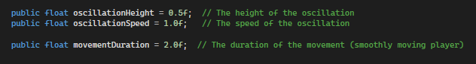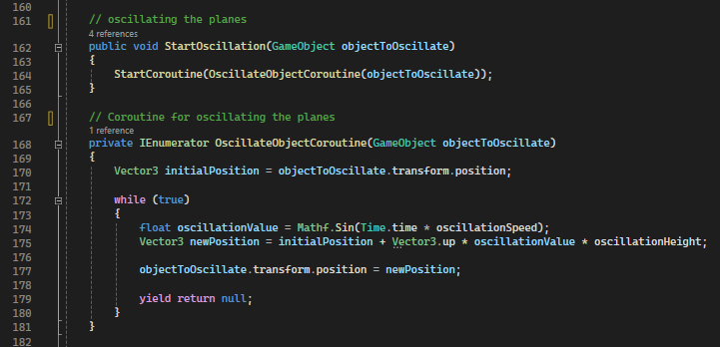

**3.** **Results and Evaluation**

Our initial project proposal was Real-time Sign Language Translation, where the program would detect sign language gestures and translate it into the user’s preferred language in the form of real-time subtitles, however, due to the level of technical expertise and resources that exceeded our current capabilities as beginners in the field of virtual reality development, we have adapted our project to a more attainable and impactful goal under the same theme, which is the creation of a virtual reality program for teaching American Sign Language (ASL) to individuals at various proficiency levels, with the same aim of facilitating their integration into society.

Additionally, designing an immersive experience for users learning ASL required careful asset selection, but our search across different platforms yielded limited options as we were limited in the usage of free assets. To tackle this, we had to get creative, tweaking and customizing the few free assets we found to fit our game's unique requirements. We utilized websites such as unity store and Fabx, **considering the trade-offs between using the available free assets and investing resources in creating or obtaining custom content to elevate the overall quality of our ASL VR game.** We found a free asset that was appropriate and suited our vision of the trip scene we had in mind initially. However, after much work in that asset, when we built and ran it in the VR, we found out that the asset is broken (was vert shaky and scattered) and does not work on the oculus meta 2. Much of our work went to waste but we thankfully found another asset, though not of the same quality and details, that we had to use towards the end of the project timeframe.

Additionally we faced many challenges during our program development that also included but is not limited to the following:

* Camera Display : running the game showed a black screen even when the main camera position was changed. Was fixed when we realized there were extra cameras in the imported assets that were conflicting with our main camera.
* Although we initially used buttons from the Oculus SDK assets, they remained inactive. We attempted a solution by downloading an additional Oculus SDK asset, but the buttons still wouldn’t click when poked by hand. Eventually, with assistance from Pi, we fixed the problem, though it is not clear to us or pi what the problem was.
* Hand tracking not working in our program, after hours of debugging, we found out that the VR’s settings we were using were not configured correctly to detect hand tracking; the problem was not from our code.
* Our feedback texts (correct and wrong words) with the dialog stayed up after each quiz and wouldn’t hide though we did SetActive(false) to them. After multiple trial and error, we learnt that Texts cannot do not have a SetActive() function and hence we had to put it under the dialog gameobject instead of separately.
* Smoothly moving the player from a position to another through multiple intervals didn’t work at the beginning. The player would directly walk to the desired position rather than stopping at the different intervals. We realized that this is because the function runs all of the smoothlywalkingplayer function at once and hence we had to put a waiting interval after each smoothlywalkingplayer function was called. We used enu

**4.** **Conclusion and Future work**

Our project, aimed at addressing the pressing need for effective ASL education through a virtual reality program, has been a journey of both technical and soft skill development. Despite its significance, accessibility to quality ASL education remains limited. Our VR program strives to bridge this educational gap by providing an immersive and interactive platform for ASL instruction, fostering integration into broader societal contexts.

The technical aspect of our endeavor involved navigating Unity, mastering C sharp programming, and understanding VR technology. Beyond conceptualizing a VR classroom, our team delved into the complexities of 3D modeling, animation, and scripting, significantly enhancing our programming and development skills. This technical exploration has not only enriched our repertoire but has also empowered us to create a comprehensive and engaging learning environment.

Looking into the future, our VR ASL classroom project presents exciting opportunities for refinement and expansion. A primary focus for enhancement involves making the program more gender-neutral, a crucial step to ensure inclusivity and increase its relevance across diverse user groups. This adjustment aligns with our commitment to creating an educational platform that resonates with users of all genders and backgrounds, fostering a welcoming and inclusive learning environment.

Furthermore, there is a keen interest in expanding our library of assets. By diversifying the range of available content, we aim to offer users a more engaging learning experience. This expansion will include a broader selection of scenes, characters, and objects, enriching the immersive educational journey within our VR ASL classroom.

An ambitious future step involves the transformation of our VR program into augmented reality (AR). This transition introduces a groundbreaking feature where hand movements can be tracked, adding a layer of realism and interactivity unparalleled in traditional VR settings. This advancement would represent a significant leap forward, providing users with an even more lifelike and responsive learning experience.

Additionally, we plan could incorporate more advanced words and sentences into our program, aiming to elevate the proficiency levels achievable through the platform. This expansion ensures that our VR ASL classroom caters to a broader audience, accommodating learners at various stages of ASL proficiency. By introducing more complexity and nuance, our program will support continuous growth and development in users' sign language skills.

These future endeavors are firmly rooted in our commitment to continuous improvement and expansion. Our goal is to enhance the impact of our VR ASL classroom, making language education not only more accessible but also more inclusive. Through these advancements, we want to empower learners across diverse backgrounds and abilities, fostering a deeper understanding and appreciation of Sign Language.

**5.** **Reflection on Learning**

Embarking on the VR classroom project provided a multifaceted learning experience that extended beyond the realm of technical skills. From a technical standpoint, delving into Unity, C sharp, and VR technology opened new doors of understanding and proficiency.

Navigating Unity, a sophisticated game development engine, demanded not only learning the intricacies of its interface but also mastering 3D modeling, animation, and scripting in C sharp. The challenge wasn't just conceptualizing a VR classroom but navigating these tools to breathe life into our vision. This technical exploration allowed us to grasp the complexities and possibilities of VR technology, enhancing our programming and development skills significantly.

Simultaneously, the project served as a crucible for developing soft skills. Time management became paramount as we juggled coursework, project deadlines, and the steep learning curve associated with new technologies. Collaborative teamwork emerged as a cornerstone, with each team member contributing unique strengths to problem-solving and execution. Regular communication and mutual support were essential, ensuring that everyone was on the same page and progressing together.

Self-dependence played a crucial role as well. Being first-year university students, the project demanded a proactive approach to learning, problem-solving, and project management. The autonomy required to navigate unfamiliar software, programming languages, and VR hardware instilled a sense of self-reliance and resourcefulness.

In summary, the project not only enriched our technical repertoire but also honed valuable soft skills. It underscored the importance of effective time management, collaborative teamwork, and individual initiative in tackling complex challenges. Beyond the development of a VR classroom for ASL, the experience laid a foundation for navigating the dynamic intersection of technology and teamwork in future academic and professional pursuits.

**6. Resources:**

[1] "4 Scientific Reasons Why Everyone Should Learn ASL - GoReact." <https://get.goreact.com/resources/scientific-reasons-why-everyone-should-learn-asl/>. Accessed 22 Oct. 2023.

[2] "Deafness and hearing loss - World Health Organization (WHO)." 27 Feb. 2023, <https://www.who.int/news-room/fact-sheets/detail/deafness-and-hearing-loss>. Accessed 22 Oct. 2023.

[3] Teacher asset

“The Best Assets for Game Making.” *Unity Asset Store*, <https://assetstore.unity.com/packages/3d/characters/humanoids/humans/elizabeth-warren-caricature-98615>. Accessed 13 Dec. 2023.

[4] classroom asset

Zip code provided by instructor Pi.

[5] Vegetable market/trip asset

Zip code provided by instructor Pi.

[6] Food items asset

“Food Free: 3D Food.” *Unity Asset Store*, <https://assetstore.unity.com/packages/3d/props/food/food-free-260726>. Accessed 13 Dec. 2023.